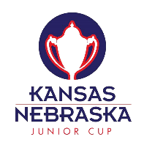

35th Kansas‐Nebraska Junior Cup Matches
Prairie Dunes Country Club
August 4‐6, 2020

PLAYER’S DINNER

Following Practice Round on August 4th
Italian Pasta Dinner – Served
Paired with Salad & Cookies
Social Distanced Table Setup

LUNCHES

Grab & Go Style Boxed Lunches
Clubhouse Wrap – August 5th
Traditional Sandwiches – August 6th
Both paired with chips, cookie, & fruit

BREAKFAST

Grab & Go Style
Breakfast Burritos – August 5th
Breakfast Sandwiches – August 6th

PLAYER & ASSOCIATION STAFF LODGING

All players and association staff will staff on property in the lodges at Prairie Dunes Country Club. Players will stay in a large cabin with a divider down the middle. Team Kansas players will stay on one side and Team Nebraska players will be on the other. There are two queen beds to a room for each bedroom.

Staff members will stay on site next door in a smaller cabin. Each staff member will have their own room. Players and staff will need a code to get in to their cabins and those will be provided at a later date as we get closer to the event.

SCORING

The URL for the online scoring page for the event is: https://www.golfgenius.com/pages/2583689. The GGID for the event will be 20KSNE.

